Integrate jenkins with git from different branches qa,dev,prod

And deployment through ec2 using declarative pipeline

-Shweta Raut

Step 1: configure Jenkins master

Step 2 : create 3 repo qa, prod, dev

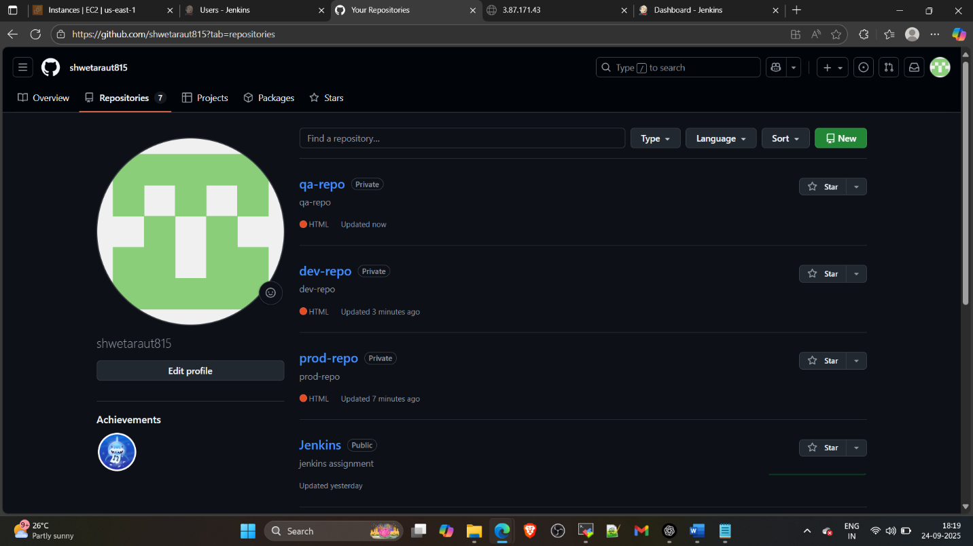

In that create 3 branches and in each branch create index.html

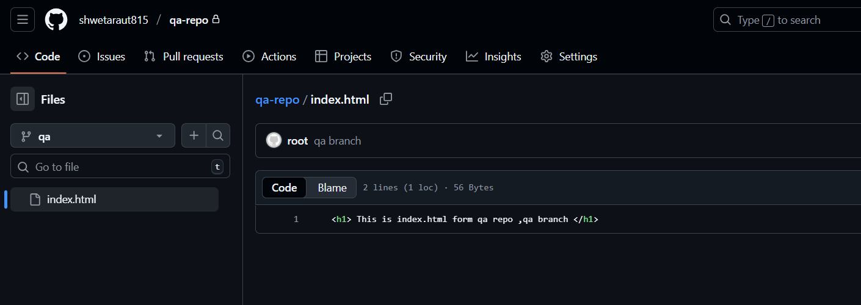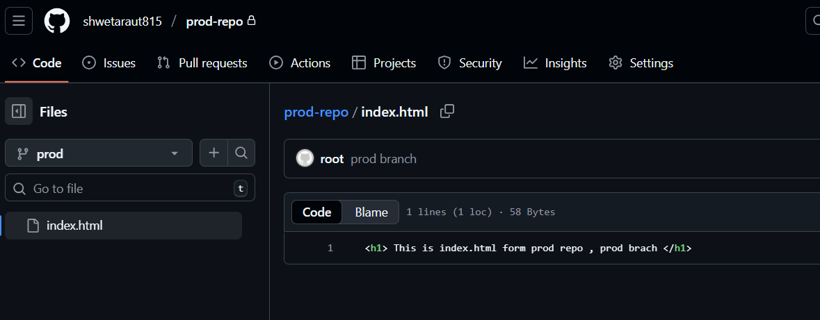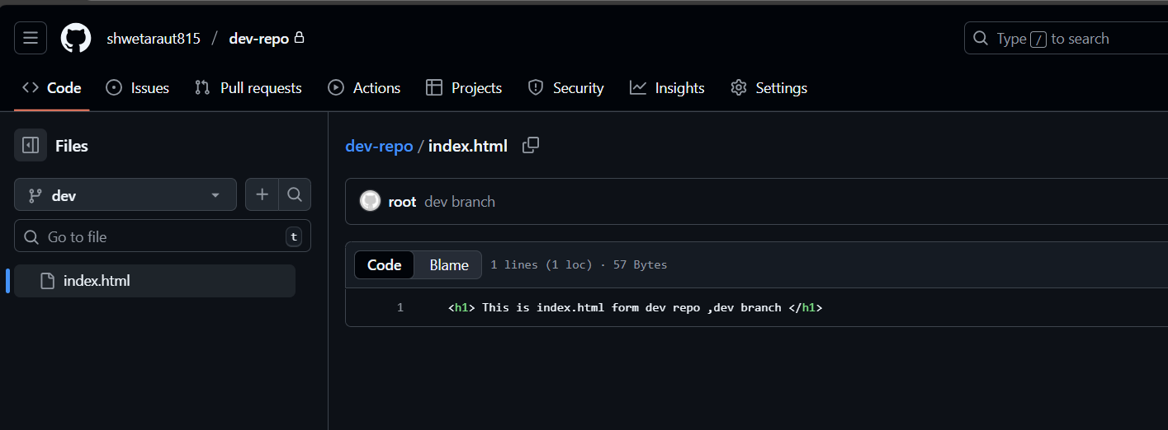

Step : create declarative pipeline

pipeline {

    agent any

    parameters {

        choice(name: 'REPO', choices: ['QA', 'PROD', 'DEV'], description: 'Select repository')

        string(name: 'BRANCH', defaultValue: 'main', description: 'Branch to deploy')

    }

    stages {

        stage('Deploy') {

            steps {

                script {

                    def repoMap = [

                        'QA': 'https://github.com/shwetaraut815/qa-repo.git',

                        'PROD': 'https://github.com/shwetaraut815/prod-repo.git',

                        'DEV': 'https://github.com/shwetaraut815/dev-repo.git'

                    ]

                    git branch: params.BRANCH, url: repoMap[params.REPO], credentialsId: 'git-tokens'

                    sh 'cp -f index.html /var/www/html'

                    sh 'chmod -R 777 /var/www/html'

                }

            }

        }

    }

}

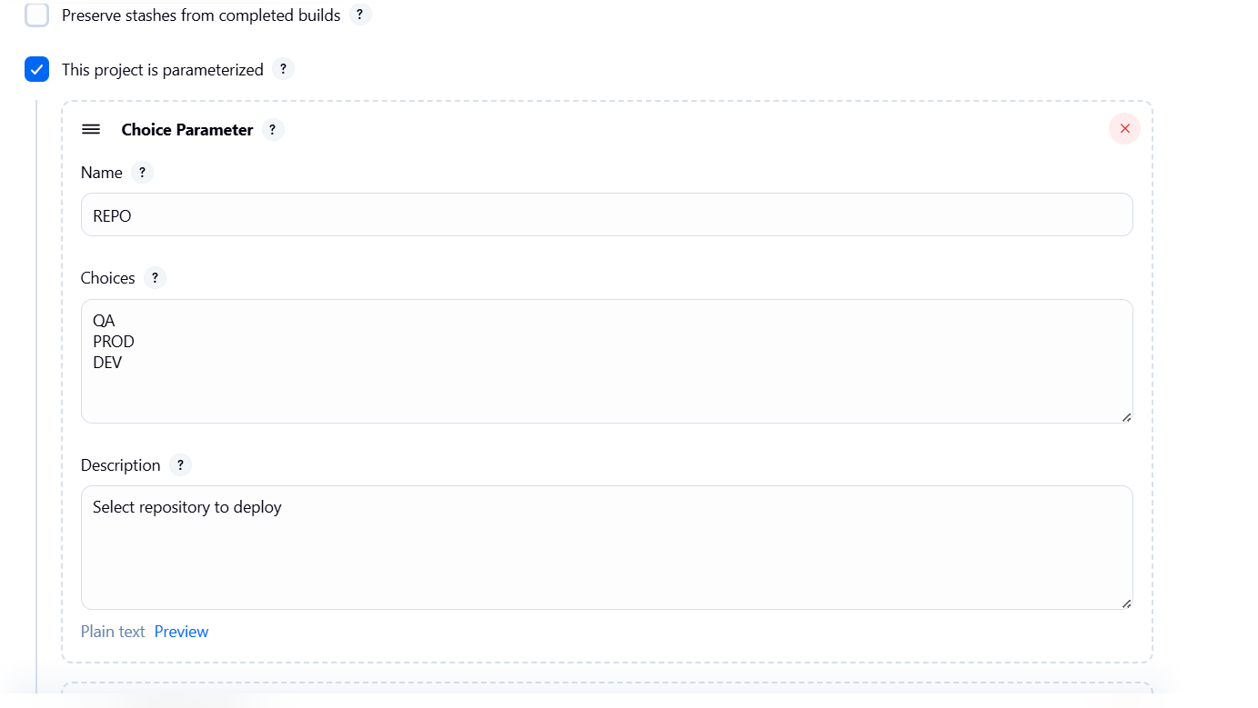

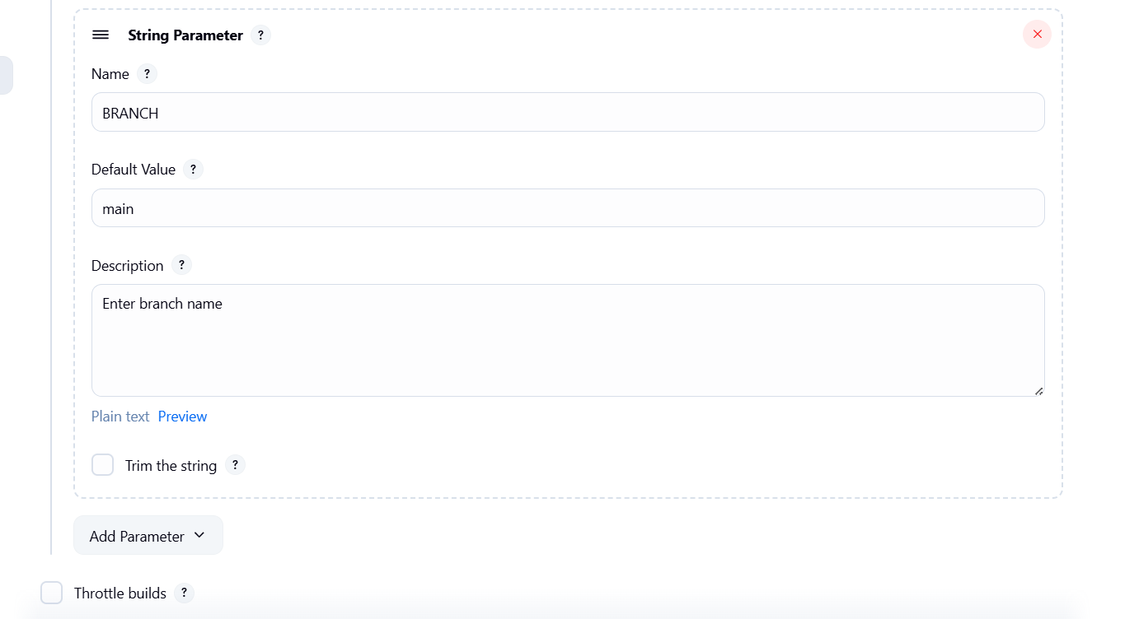

Now build the job with parameter

